ABORIGINAL COALITION TO END HOMELESSNESS
View Our Digital Story

Tuesday September 6, 2016
Our Place - Chapel
10:30 am – 12:00pm

We invite you to join us to view our Digital Stories, of which many of you were apart of.
An opportunity to connect and share goal setting strategies.
Snacks will be provided.

This event is only for Aboriginal (First Nations, Inuit, Métis) community members who are experiencing homelessness

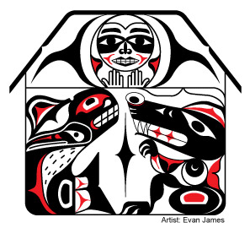

**we acknowledge the unceded Coast Salish territories that we are on**

ABORIGINAL COALITION TO END HOMELESSNESS
View Our Digital Story

Tuesday September 6, 2016
Our Place - Chapel
10:30 am – 12:00pm

We invite you to join us to view our Digital Stories, of which many of you were apart of.
An opportunity to connect and share goal setting strategies.
Snacks will be provided.

This event is only for Aboriginal (First Nations, Inuit, Métis) community members who are experiencing homelessness

**we acknowledge the unceded Coast Salish territories that we are on**

ABORIGINAL COALITION TO END HOMELESSNESS
View Our Digital Story

Tuesday September 6, 2016
Our Place - Chapel
10:30 am – 12:00pm

We invite you to join us to view our Digital Stories, of which many of you were apart of.
An opportunity to connect and share goal setting strategies.
Snacks will be provided.

This event is only for Aboriginal (First Nations, Inuit, Métis) community members who are experiencing homelessness

**we acknowledge the unceded Coast Salish territories that we are on**

ABORIGINAL COALITION TO END HOMELESSNESS
View Our Digital Story

Tuesday September 6, 2016
Our Place - Chapel
10:30 am – 12:00pm

We invite you to join us to view our Digital Stories, of which many of you were apart of.
An opportunity to connect and share goal setting strategies.
Snacks will be provided.

This event is only for Aboriginal (First Nations, Inuit, Métis) community members who are experiencing homelessness

**we acknowledge the unceded Coast Salish territories that we are on**

